**Name: Harshal Karbhari Zarikar**

**Cancer Prediction Using Machine Learning Approach**

**Introduction**

Cancer remains a significant global health concern, with early detection proving crucial for improved patient outcomes. Traditional diagnostic methods, while effective, can be expensive, invasive, and time-consuming. This report explores the potential of a machine learning-based system for cancer prediction, aiming to empower healthcare professionals with a non-invasive and efficient tool for early detection.

**1. Problem Statement**

Cancer remains a leading cause of mortality worldwide. Early detection is crucial for successful treatment and improved patient outcomes. However, traditional diagnostic methods can be expensive, invasive, and time-consuming. This project aims to develop a machine learning-based system for cancer prediction, enabling earlier detection and improved healthcare outcomes.

Cancer usecase diagram

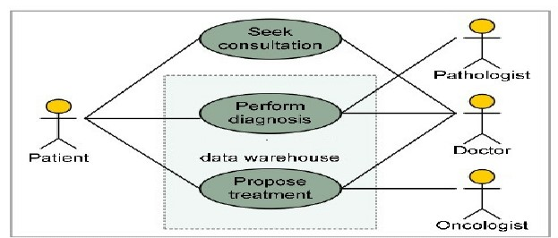

**2. Market/Customer/Business Need Assessment**

The target market for this project encompasses various stakeholders:

* **Healthcare providers:** The system can assist doctors in identifying patients at high risk for cancer, leading to earlier intervention and improved treatment decisions.
* **Patients:** Early detection empowers patients to take proactive steps towards their health and potentially improve their prognosis.
* **Pharmaceutical companies:** The system can be used for patient stratification in clinical trials and drug development.

**3. Target Specifications and Characterization**

The ideal customer is a healthcare provider or institution seeking a non-invasive and cost-effective tool for early cancer detection. The system should:

* **Accuracy:** Achieve high accuracy in predicting cancer with a low false-positive rate.
* **Ease of Use:** Integrate seamlessly with existing healthcare workflows.
* **Scalability:** Be adaptable to various cancer types and data sources.
* **Interpretability:** Provide clear explanations for its predictions, fostering trust among medical professionals.

Customer Characterization:

1. **Healthcare Providers and Institutions**: The primary target customers are healthcare providers and institutions including hospitals, clinics, diagnostic centers, and research institutions involved in cancer screening, diagnosis, and treatment.
2. **Decision Makers**: The target customer includes decision-makers within healthcare organizations, such as chief medical officers, directors of oncology departments, heads of research divisions, and other key stakeholders involved in purchasing decisions.
3. **Medical Professionals**: Oncologists, radiologists, pathologists, and other medical professionals directly involved in cancer diagnosis and treatment are key users of the system.
4. **Research Institutions**: Academic and research institutions focused on cancer research and clinical trials may also be potential customers, especially those interested in utilizing advanced technology for early detection and monitoring of cancer.
5. **Healthcare Administrators**: Administrators responsible for managing healthcare facilities, budgets, and resources are also important customers as they play a significant role in implementing new technologies within healthcare systems.
6. **Diagnostic Centers and Laboratories**: Facilities specialized in diagnostic testing and pathology services are potential customers, particularly those looking to enhance their capabilities in cancer detection and diagnosis.
7. **Technology Adoption Enthusiasts**: Healthcare professionals and organizations with a proactive approach to adopting innovative technologies for improving patient care and outcomes are likely to be early adopters of the system.
8. **Cost-Conscious Customers**: Healthcare providers and institutions seeking cost-effective solutions for cancer detection and diagnosis, particularly in resource-constrained settings or regions with limited access to advanced medical technology, are part of the target market.
9. **Quality-Conscious Customers**: Customers who prioritize accuracy, reliability, and interpretability of diagnostic tools and technologies, aiming to provide the highest standard of care to their patients, are also within the target audience.
10. **Collaborative Institutions**: Organizations open to collaboration and partnership with technology providers for the development and refinement of cancer detection tools and techniques are potential customers interested in long-term relationships for mutual benefit and advancement in cancer care.

**4. External Search**

* National Cancer Institute: <https://www.cancer.gov/>
* American Cancer Society: <https://www.cancer.org/>
* Scholarly articles on cancer prediction using machine learning (e.g., <https://sist.sathyabama.ac.in/sist_naac/documents/1.3.4/1822-b.e-cse-batchno-53.pdf>)

**5. Benchmarking Alternate Products**

Existing cancer screening methods include mammograms, colonoscopies, and blood tests. These methods can be expensive, require specialized equipment, or be invasive.  
Some AI-powered cancer detection tools are emerging, but many focus on specific cancers or require integration with expensive imaging technologies.

**6. Applicable Patents** (further research required)

* Machine learning algorithms for cancer prediction might be patented. A patent search is recommended during later development stages.

**7. Applicable Regulations**

* HIPAA (Health Insurance Portability and Accountability Act) ensures patient data privacy.
* FDA (Food and Drug Administration) approval may be required for clinical use.

**8. Applicable Constraints**

* Access to a large and diverse dataset of labeled medical data for training the machine learning model.
* Computational resources for running complex algorithms.
* Expertise in machine learning, healthcare data analysis, and regulatory compliance.

**9. Business Model**

* Subscription-based service for healthcare institutions.
* Pay-per-use model for individual patient risk assessments.
* Partnership with pharmaceutical companies for patient stratification.

**10. Concept Generation**

The core idea is a machine learning system that analyzes various data points to predict cancer risk.

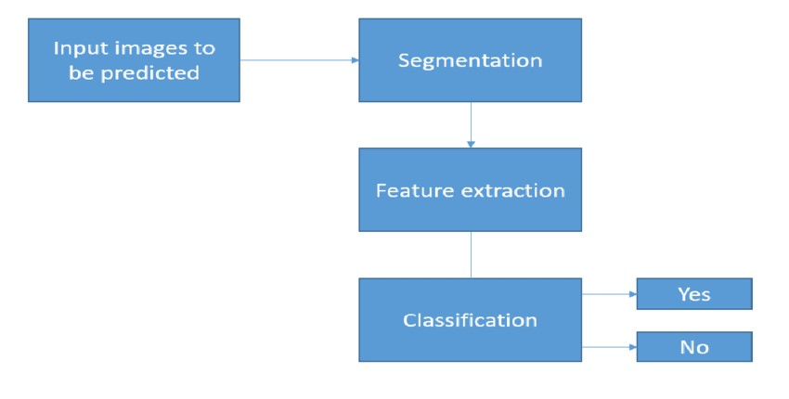

**11. Concept Development**

The system will collect patient data, including:

* Demographic information
* Medical history
* Laboratory test results
* Imaging data (if available)

The data will be preprocessed and fed into a machine learning model trained to identify patterns associated with cancer. The model will then generate a risk score for each patient.

**12. Final Product Prototype (Abstract) with Schematic Diagram**

**Abstract:**

The Cancer Prediction System (CPS) is a web-based platform that utilizes machine learning to assess an individual's risk of developing cancer. Doctors can input patient data, and the CPS will output a risk score alongside an interpretation of the factors contributing to the score.

1. **Health Insurance Companies**:
   * Health insurance companies are interested in proactive healthcare and risk management. They could collaborate with the Cancer Prediction App by providing access to their user base for personalized risk assessments. In return, they may offer a commission, such as 20% of the premium revenue generated from users referred by the app.
2. **Pharmaceutical Companies**:
   * Pharmaceutical companies developing cancer treatments or prevention drugs could collaborate with the Cancer Prediction App by accessing user data for research purposes. They may pay a commission for access to aggregated and anonymized data or collaborate on joint initiatives aimed at improving cancer outcomes.
3. **Healthcare Institutions**:
   * Healthcare institutions, such as hospitals and clinics, play a crucial role in patient care and could benefit from the insights provided by the Cancer Prediction App. They may collaborate by referring patients to the app for personalized risk assessments and receiving recommendations. In return, they could offer a commission of 20% for each patient referred who undergoes a risk assessment through the app.

These collaborations would involve revenue-sharing agreements or commission-based models where partners compensate the Cancer Prediction App for the value it provides in identifying cancer risks and providing recommendations to patients.

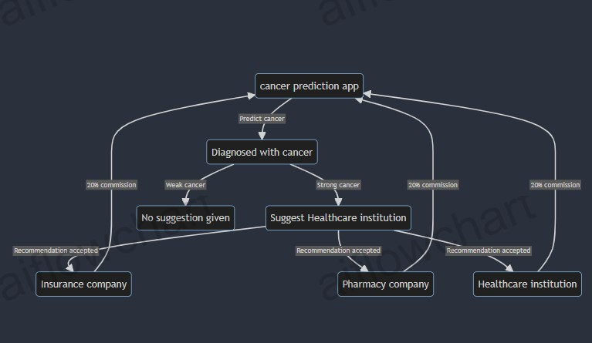

Schematic diagram of cancer prediction app

**13. Product Details**

**How does it work?**

**Product Name: Cancer Prediction App**

**Overview:** The Cancer Prediction App is a user-friendly mobile application designed to assess an individual's risk of developing cancer using advanced machine learning algorithms. By analyzing various factors such as demographic information, medical history, lifestyle choices, and genetic predispositions, the app provides personalized risk assessments and recommendations for early detection and prevention strategies.

**Features:**

1. **User Registration and Profile Creation:**
   * Users can create accounts and input their personal information, including age, gender, family history of cancer, lifestyle habits, and any existing medical conditions.
2. **Data Collection and Analysis:**
   * The app collects and analyzes user data using machine learning algorithms to generate personalized risk assessments for different types of cancer, such as breast cancer, lung cancer, colorectal cancer, etc.
3. **Risk Assessment:**
   * Based on the input data, the app calculates the user's risk score for developing various types of cancer. The risk score is presented in an easy-to-understand format, indicating the likelihood of developing cancer over a specified period.
4. **Recommendations and Insights:**
   * The app provides personalized recommendations and insights based on the user's risk assessment. This may include lifestyle modifications, preventive screenings, genetic testing recommendations, and referrals to healthcare professionals for further evaluation.
5. **Integration with Healthcare Providers:**
   * The app facilitates seamless collaboration with healthcare institutions, allowing users to share their risk assessment reports with their healthcare providers for further consultation and follow-up.
6. **Continuous Monitoring and Updates:**
   * Users can regularly update their profiles and receive ongoing monitoring of their cancer risk status. The app sends notifications and updates based on the latest research and advancements in cancer prevention and early detection strategies.

**How it Works:**

1. **User Input:**
   * Users create an account and provide relevant personal and medical information through the app.
2. **Data Analysis:**
   * The app's machine learning algorithms analyze the user's input data, including demographic details, medical history, lifestyle factors, and genetic information.
3. **Risk Assessment:**
   * Based on the analysis, the app generates a personalized risk assessment report for the user, indicating their risk of developing various types of cancer.
4. **Recommendations:**
   * The app provides tailored recommendations and insights to help users mitigate their cancer risk, such as lifestyle changes, screening recommendations, and genetic testing options.
5. **Collaboration with Healthcare Providers:**
   * Users can share their risk assessment reports with their healthcare providers for further evaluation and discussion.
6. **Continuous Monitoring:**
   * The app offers ongoing monitoring of the user's cancer risk status and provides updates and recommendations based on the latest research and medical guidelines.

**Target Audience:** The Cancer Prediction App targets individuals interested in proactive healthcare and cancer prevention, as well as healthcare professionals seeking to provide personalized recommendations to their patients for early detection and prevention of cancer.

Overall, the Cancer Prediction App aims to empower users with personalized insights and recommendations to help them make informed decisions about their health and well-being in the context of cancer prevention and early detection.

Top of Form

1. Doctors upload patient data onto the CPS platform.
2. The system preprocesses the data (handling missing values, formatting)
3. Feature engineering techniques extract relevant features from the data.
4. The machine learning model analyzes the features and generates a cancer risk score.
5. The system provides the score along with explanations for the contributing factors.

**Data Sources**

* Electronic health records
* Laboratory results
* Imaging data (optional)

**Algorithms, frameworks, software etc. needed**

* Machine learning algorithms (e.g., Random Forest, Support Vector Machine)
* Data science libraries (e.g., TensorFlow, PyTorch)
* Cloud computing platform for scalability

**Conclusion:**

AI is set to change the medical industry in the coming decades — it wouldn’t make sense for pathology to not be disrupted too. Currently, ML models are still in the testing and experimentation phase for cancer prognoses. As datasets are getting larger and of higher quality, researchers are building increasingly accurate models.

While we might not see AI doing the job of a pathologist today, we can expect ML to replace our local pathologist in the coming decades, and it’s pretty exciting! ML models still have a long way to go, most models still lack sufficient data and suffer from bias. Machine learning can train just as well as doctor prognosis, it doesn’t require extra pay for prognosis. Manual cancer treatment take long time to show the result ,while machine learning gives output in seconds .To save people’s life and allow doctor to fully concentrate in diagnosis, Yet, something we are certain of is that ML is the next step of pathology, and it will disrupt the industry.